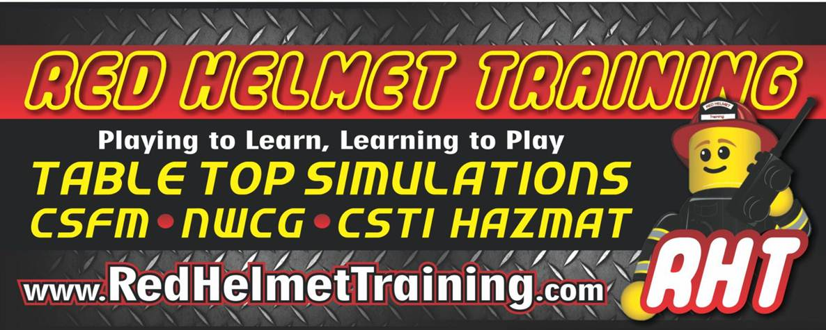

The Art of Reading Buildings
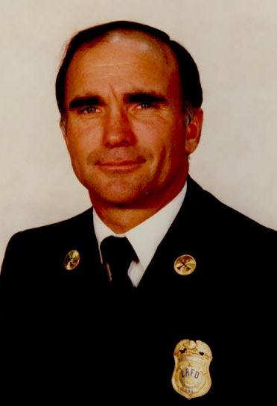
on June 19th with Chief John Mittendorf (Ret. LA City Fire)
This class will take a whole new approach to reading residential-commercial
buildings and is designed to provide essential tools that are based on a simple
four-step method to assist in making rapid street-reads.

These reads will assist in determining the factors of strength, weaknesses,
collapse hazards, new construction features, and evaluating fireground time
as the time necessary to accomplish any fireground operation is one of the
foundations of safe and effective operations.

Once attendees are introduced to the four-step method of reading buildings,
multiple 360-degree perimeter videos will allow the opportunity to practice
Instructor Bio
the four-step rapid street-read method.

SLAB SAVERS Strategy & Tactics
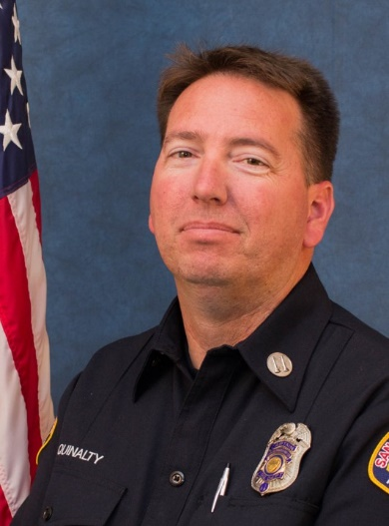
June 20th with Captain Jesse Quinalty (Red Helmet Training)
This program uses the SLAB (Safety Profile, Life Profile, Air Track and Building)
and utilizes the information to come up with the Strategy. More importantly
whether the fire is offensive or defensive based on this situational awareness
and 360 walk around. It is aligned with the IAFC Rules of Engagement and the
Everyone Goes Home Program to work through a risk vs. gain process.

The program then looks at how to develop tasks and tactics for this strategy
using the division of labor. The tactics are assigned based on SAVERS.

This interactive course uses digital simulation and dash cam videos to enhance
the rapid decision-making process. This course reviews command elements
Instructor Bio
with a focus on new fire behavior, risk assessment and control of resources.

This course will be hosted at the Tahoe-Douglas Fire Protection District
LOCATION: 193 Elks Point Road Zephyr Cove, NV 89448
DATES: June 19 and 20, 2018 TIMES: 0900 – 1700 hours
REGISTER on our website: www.RedHelmetTraining.com
$100 for one day or $175 for both

